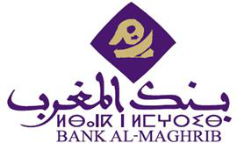

**Opening Remarks by the Director General**



Mr. President of UNEP-FI, Dear representatives of the Africa and Middle East



On the other hand, most of the financed projects



investments. Experiences in



On this point, I would